|  |
| --- |
| Orange HRM Live Project |
| **Project Functional Requirement Specification Version 1** |
|  |
| **Prepared by: Anna Shobi(845207)**  **Reviewed by : Raghavendra BN** |
|  |
|  |
|  |

|  |
| --- |
|  |

Contents

1. Purpose of the document: 3

2. Project Overview: 3

2.1 Audience: 3

2.2 Hardware and Hosting: 3

3. Information Architecture 4

3.1 Admin Module 4

3.1.1 User Manager Module 4

3.1.2 Job 5

3.1.3 Organization 8

3.1.4 Qualification 10

3.1.5 Nationalities 12

4.Sign-Off Document 14

# Purpose of the document:

This is **not** a project plan. It is a guide for system architecture and development, not for phasing, timelines or deliverables.

This document is divided into three sections:

• Project Overview

• Information Architecture

• Site Design

# Project Overview:

## 2.1 Audience:

This document is intended as a complete guide for ESS-User in using Orange HRM 3.0. This

Document is specially designed for non-specialists; specialists may find the document a useful point of reference. By reading this guide, you will learn how to use Orange HRM through the elements of the graphical user interface and what's behind some of the advanced features that are not always obvious at first sight. It will hopefully guide you around some common problems that frequently appear for users of Orange HRM.

## 2.2 Hardware and Hosting:

Orange HRM’s servers will be hosted at X company’s site.

Orange HRM will be hosted on two servers: One to host the actual website and (language) code, and the other to host the (database name) database.

# Information Architecture

Log in to the Orange HRM System using your ESS-User account that has been created by the HR Admin

As shown in the figure 3.1

Figure 3.1:

.

## 3.1 Admin Module

The Admin Module is a very helpful tool where the system admin or the HR team can edit the details of the employees who all are working in the organization. It is through this module where the admin can give access to the employees to make modifications in the system.

The services that this module provides are so vast and almost cover up the entire system. The admin can add the new options or fields and the employees can even give information on. It is through this module the admin can add new users who can add their data.

### 3.1.1 User Manager Module

* Users

When an Admin-User logs into the system for the first time, the first thing they will see is the “Users” screen as shown in Figure 3.1.1. They are able to edit and enter the details of new user’s username, Employee name and status.

They can search the employees by typing their user id or employee name, user role or status

Figure 3.1.1:

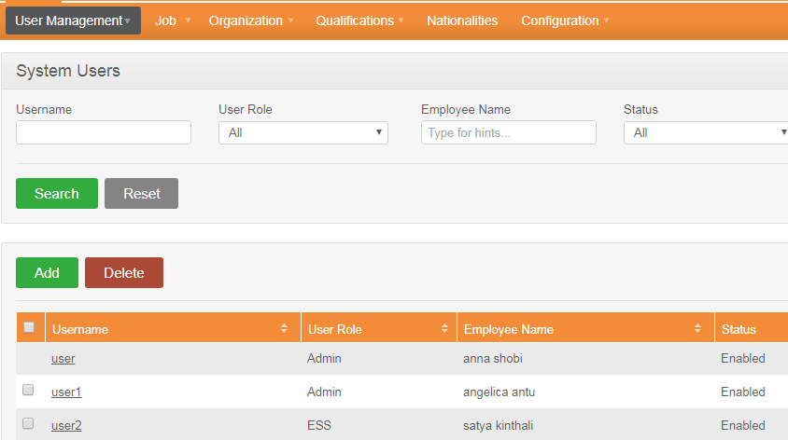

The admin can assign a user either as an admin or ESS user and can change their status either Enable or Disable. The admin can even give permission to change the password to the other users

### 3.1.2 Job

* Job Title

Figure 3.1.2:

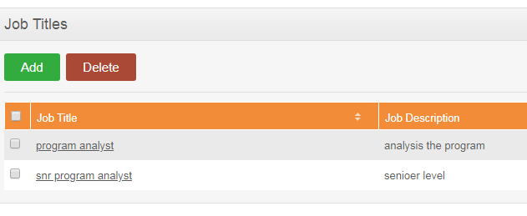

Here the admin can add new job titles and a can give descriptions about the new job types, He can also add attachments under this and save so when a new user enters their details they can choose from this list.

* Pay grades

The admin can fix the pay grades for different designations in the company and can specify the currency also .The maximum and the minimum pay scales can also be mentioned under each designations

Figure 3.1.3:

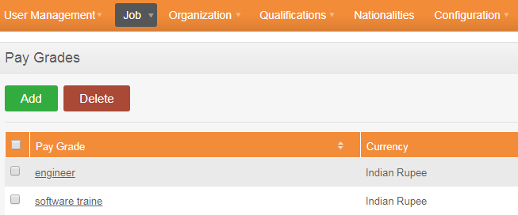

* Employment status

Figure 3.1.4:

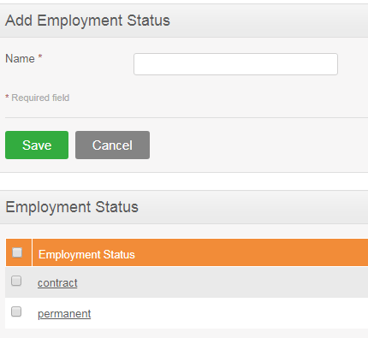

The employment statuses can be added to the profiles through this sub module.

* Job category

Figure 3.1.5:

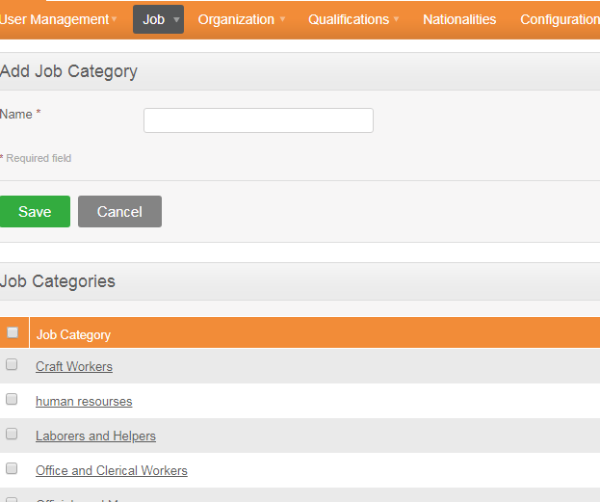

There are many categories that are already mentioned if wanted can add even more categories in this list

* Work Shifts

Figure 3.1.6:

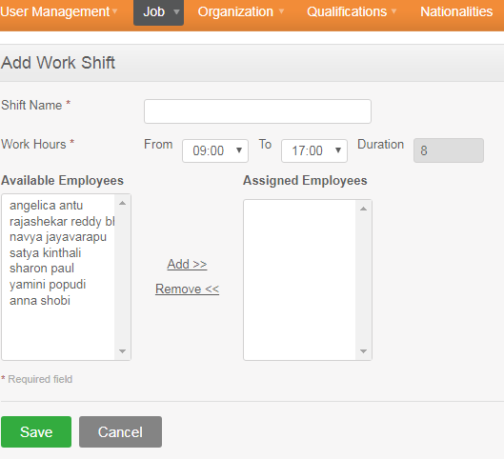

The admin can add new shifts with its name, their working hours and also can assign the different employees who all are available and free during those working hours

### 3.1.3 Organization

Figure 3.1.7:

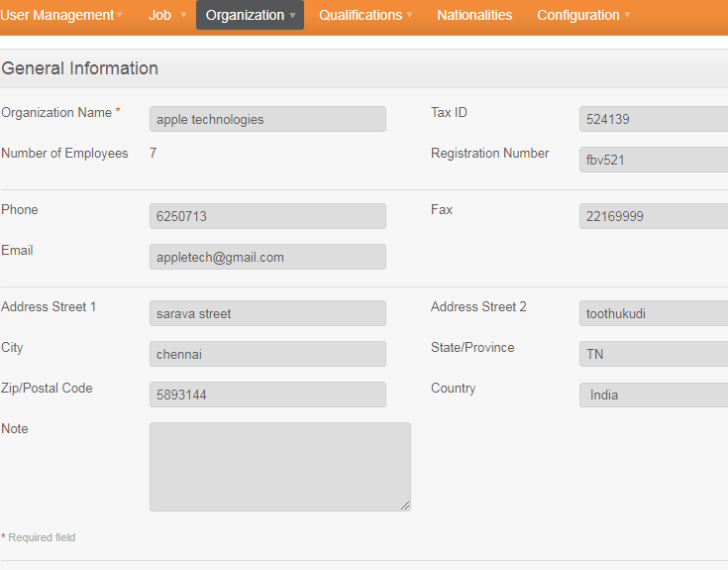

Details regarding the organization can be edited and saved in this module.

Click “Edit” to enter the information.

You can edit the following:

• Organization Name

• Tax ID

• Registration number

• Phone

• FAX

• email ID

• Street 1

• Street 2

• City/Town

• State/Province – If the country is United Sates you can select from the drop down or you need to enter it manually

• ZIP Code

• Country

• NOTE

Once you have completed this form click “Save”.

* Locations

Figure 3.1.8:

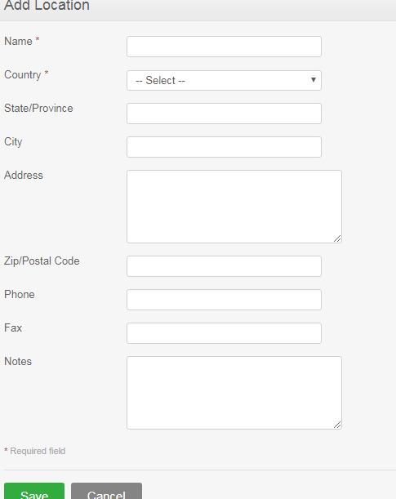

If the organization has other offices other states or country the information regarding that can be filled inside this module. This information will be shown up when employees enter their details.

* Structure

Figure 3.1.9:

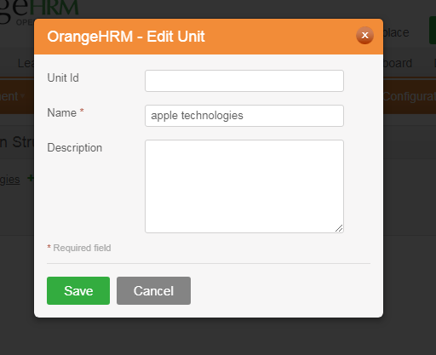

We can add the branch ID or unit ID that is specific for one branch alone.

### 3.1.4 Qualification

There are many options and information that have to be filled up by the staffs in their my Info sections .in this module the admin will add up all the details such as skills ,education ,Licenses ,languages known ,Memberships.

* Skills

Figure 3.1.10:

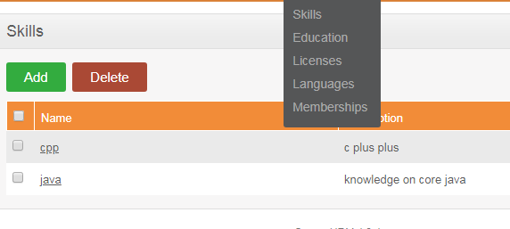

This will make the list of skills available while filling up the skills section in my info .The admin can add as much skills he want and have to show some descriptions about each one.

* Education

Figure 3.1.11:

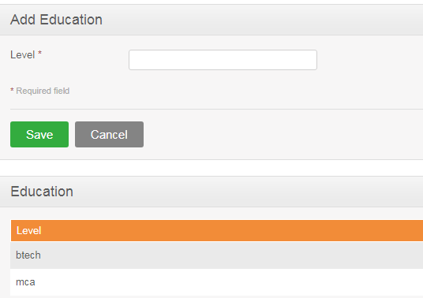

The admin will add the type of graduates it can have and add the education details in my info based on the list provided by the Admin in this section.

* Licence

Different types of licences that the employees should have will be entered here and can be saved under this module

Figure 3.1.12:

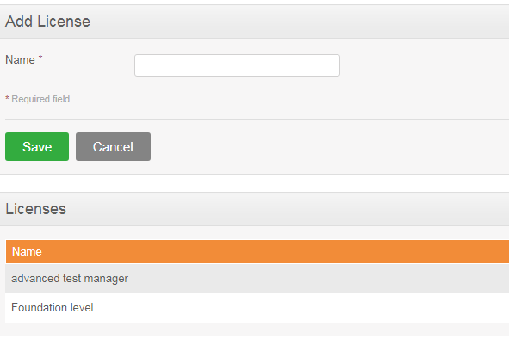

* Languages

Figure 3.1.13:

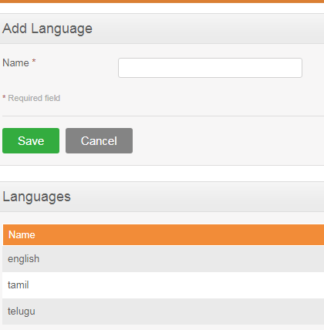

The language skills can be added here. The admin just need to select the add button and enter the new details and press the save button.

* Memberships

The membership details can be added in this section so the staffs while they update their details section can choose from this list given by the Admin. This data can be edited at any time.

Figure 3.1.14:

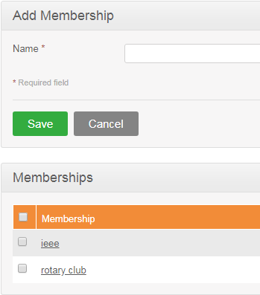

### 3.1.5 Nationalities

Figure 3.1.15:

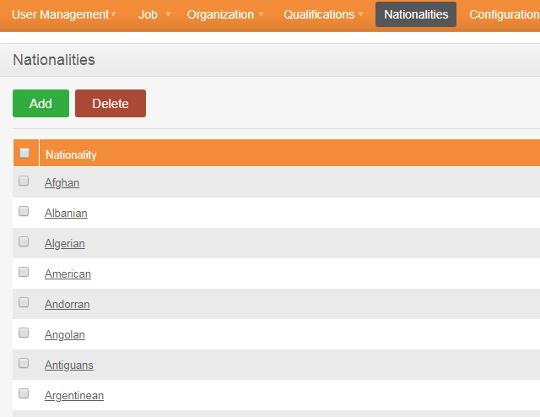

In this module the admin can add the list of countries into this platform. We will get access of these countries in any sections of this application. Whenever the list of countries appears in these applications the list is shown up from this list.

As default settings a set of countries is already written down if more have to be added the admin can just add on the new countries on this already existing list.

In the figure we can see the add button so by pressing that we can add on the additional countries any we just have to press save button after that.

# 11. Sign-Off Document

_____________________________________________________________________________

The following parties have read and agree with this Requirements Definition document for the Orange HRM application account module functionality.

After approval of this Requirements Definition phase, any significant changes in the scope of this project will require validation of existing project costs and schedules.

_______________________________________________________________________

Name Date

Business Lead

______________________________________________________________________

Name Date

Project Manager

|  |
| --- |
| **Prepared by : Anna Shobi(845207)** |
|  |